**Solar Resource Uncertainty (SOLARUN) Application**

**Scope**: Application provides a GUI interface to calculate uncertainty in data measurement of different instruments for components like calibration, Zenith response, Azimuth response, Spectral response, Tilt response, Nonlinearity, Temperature response, Aging per year, Datalogger, maintenance, etc. For each component there are 5 configuration options (acts on input / output quantity, ﻿uncertainty type, ﻿distribution, symmetry and analysis).

**OS Support:**  Windows and Macintosh.

**Input:** For this application to run precisely, required is an excel file with 2 sheets named: ‘Data’ and ‘List’ (please see the required format).

**# ‘Data’ Sheet:**

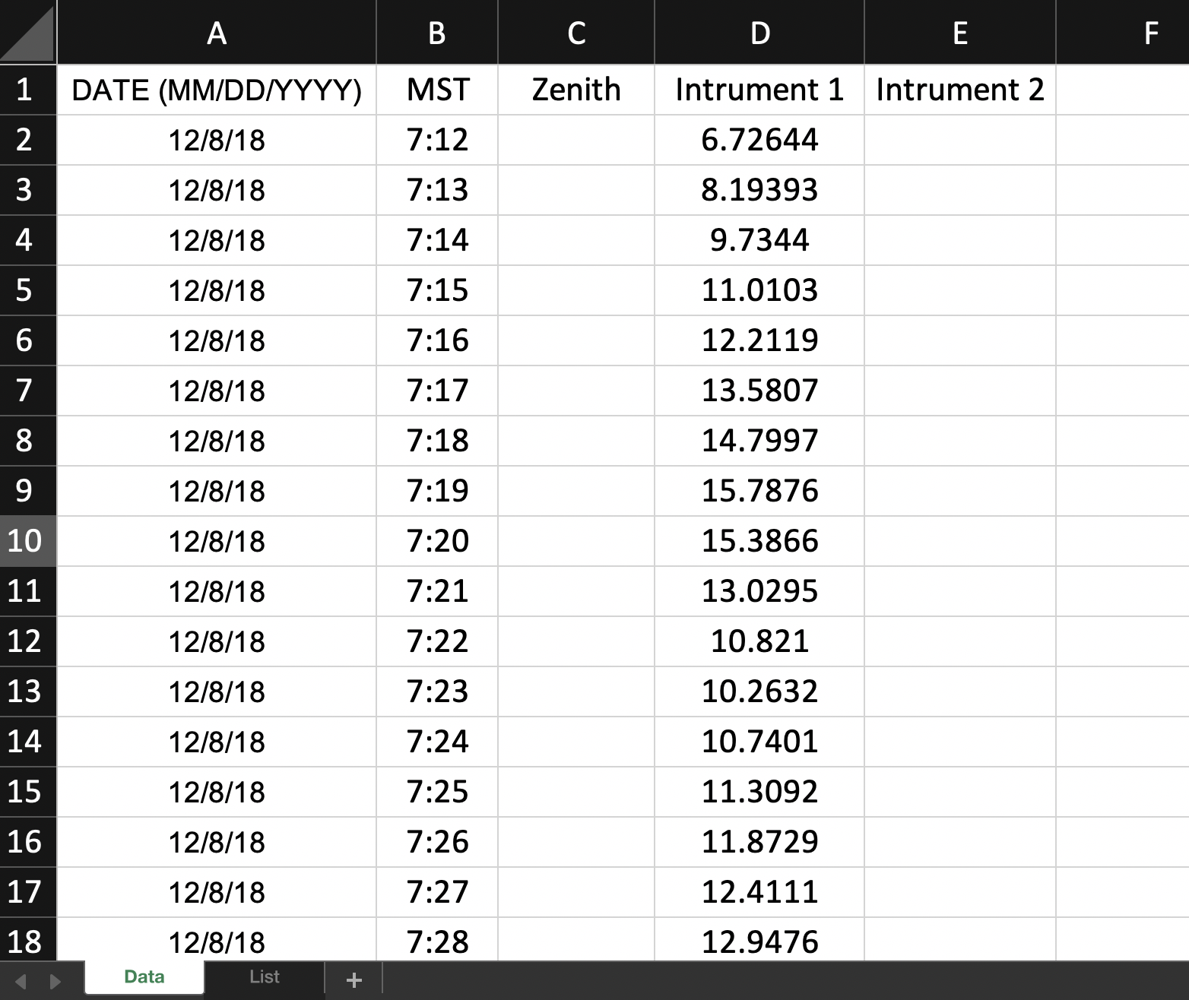

**# ‘List’ Sheet:**

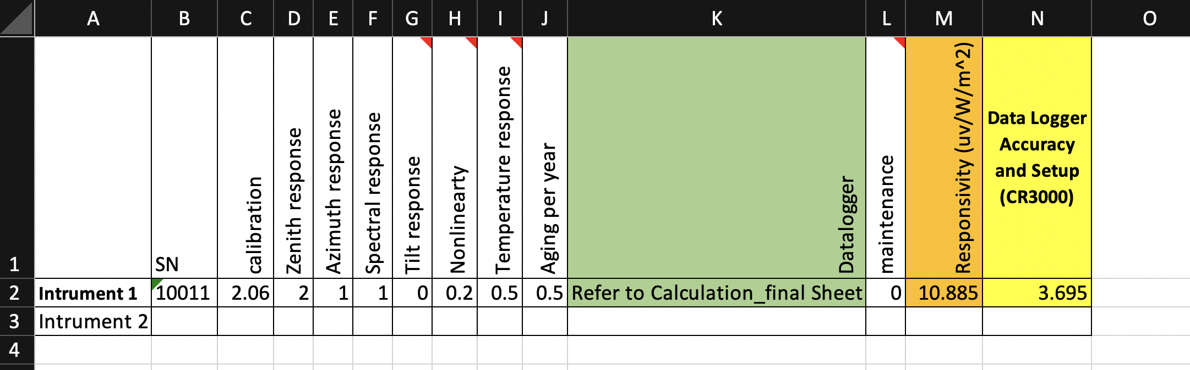

**Output:** Once the excel sheet and configuration in put is provided the application generates an Excel as output result with 4 sheets and 2 graphs:

1: Final Uncertainty: Calculated Uncertainty for selected instrument in W/m2 and percentage.

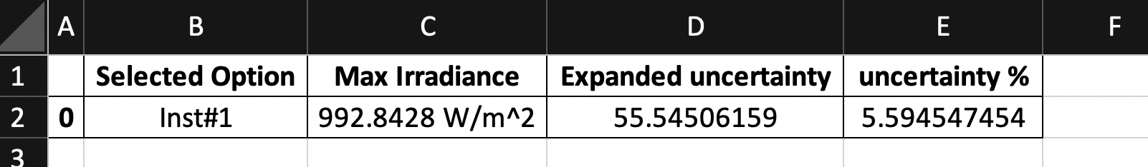

2: Exp & Std Uncert: Expanded and standard uncertainty for the components.

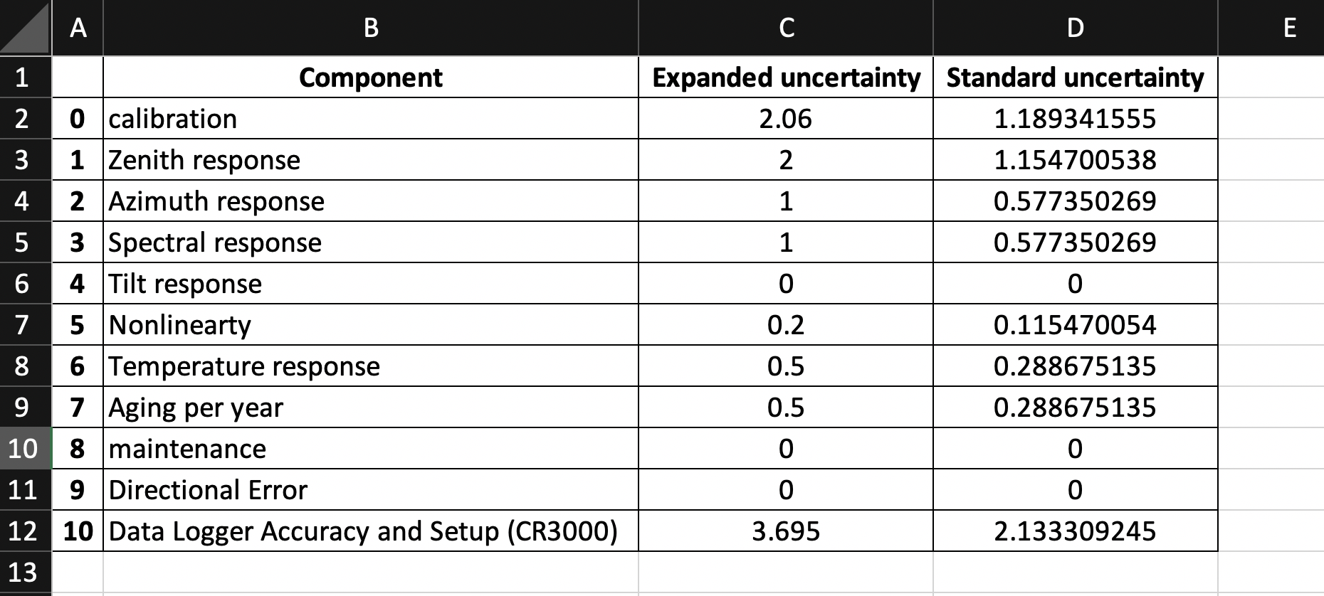

3: Selected Features: Sections made for each component.

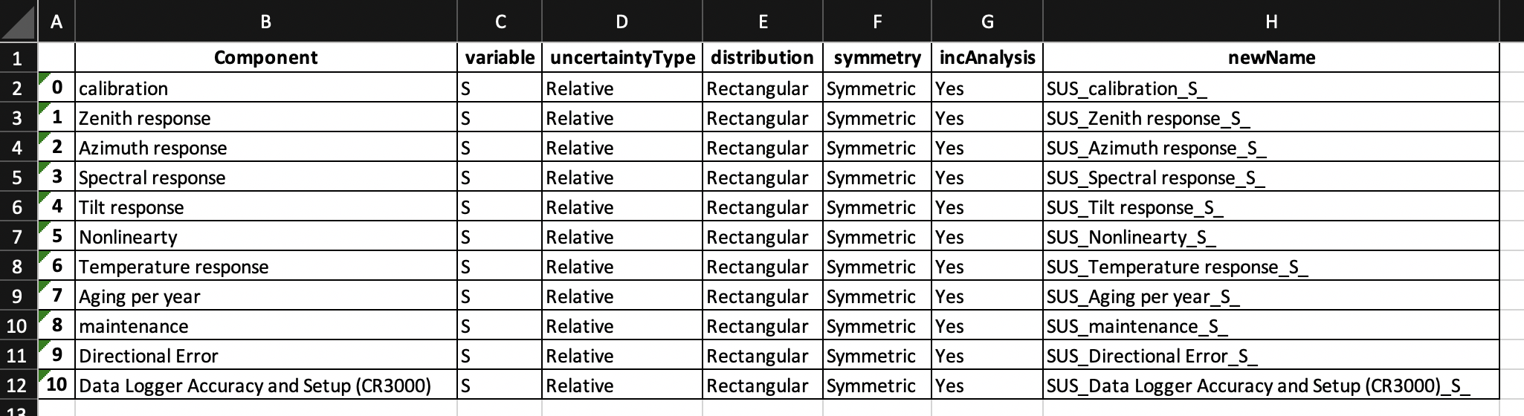

4: Final Calculation: A detailed calculation to evaluate uncertainty.

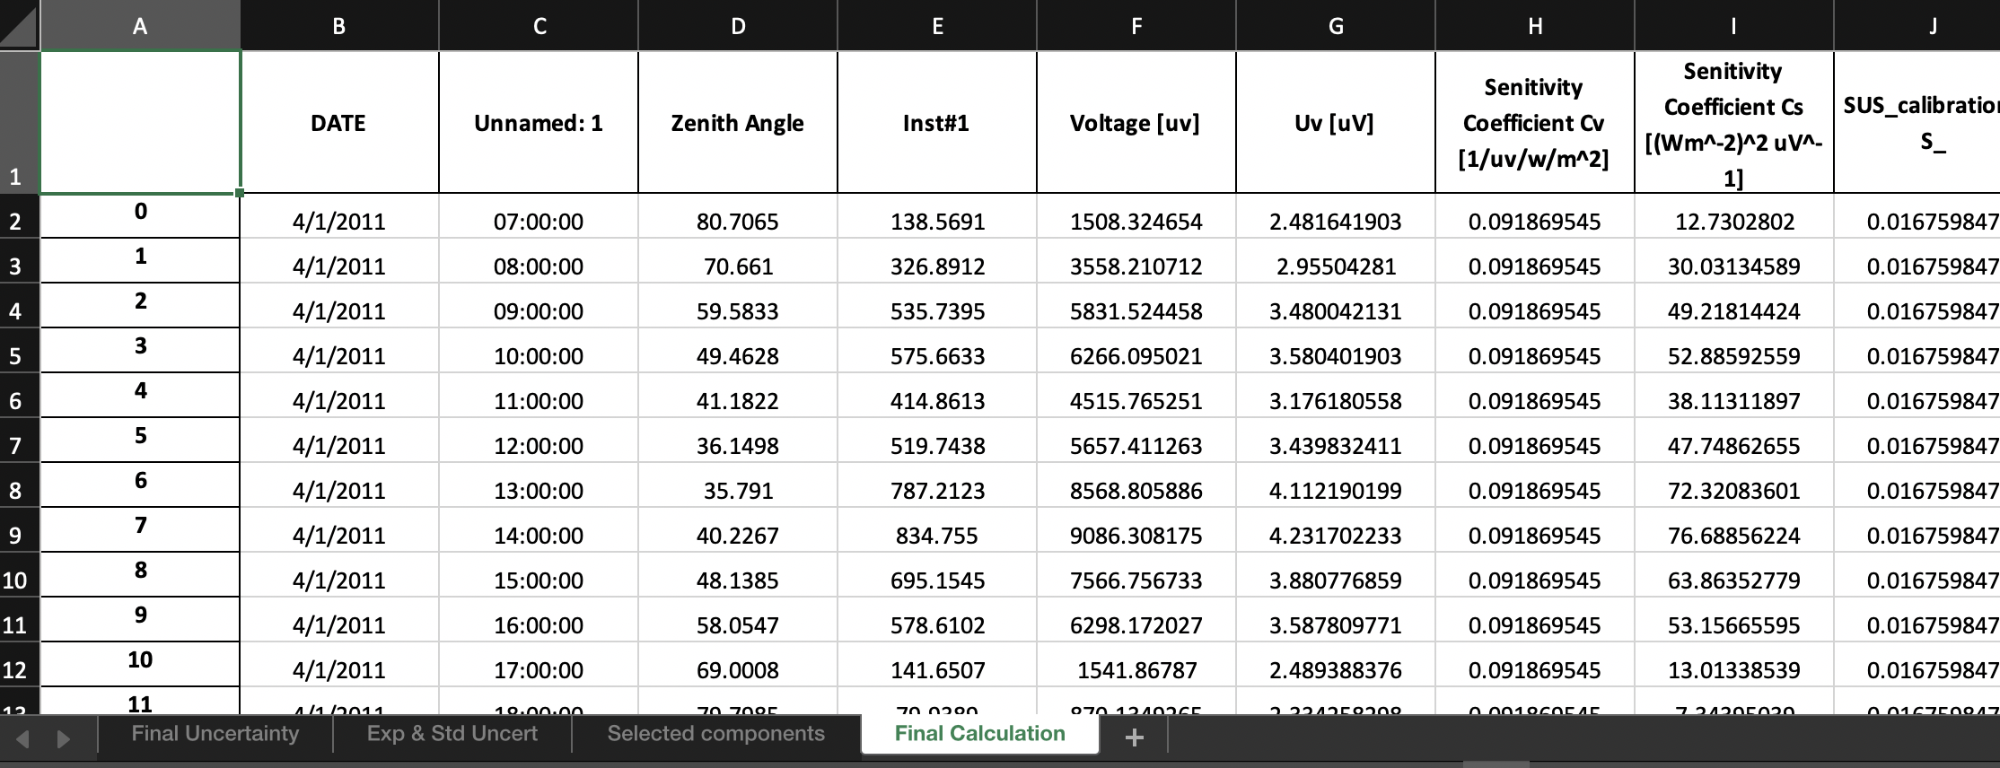

* Graph #1:

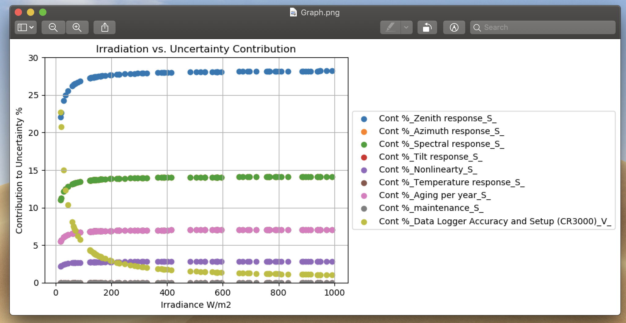

* Graph #2: For Hourly Data

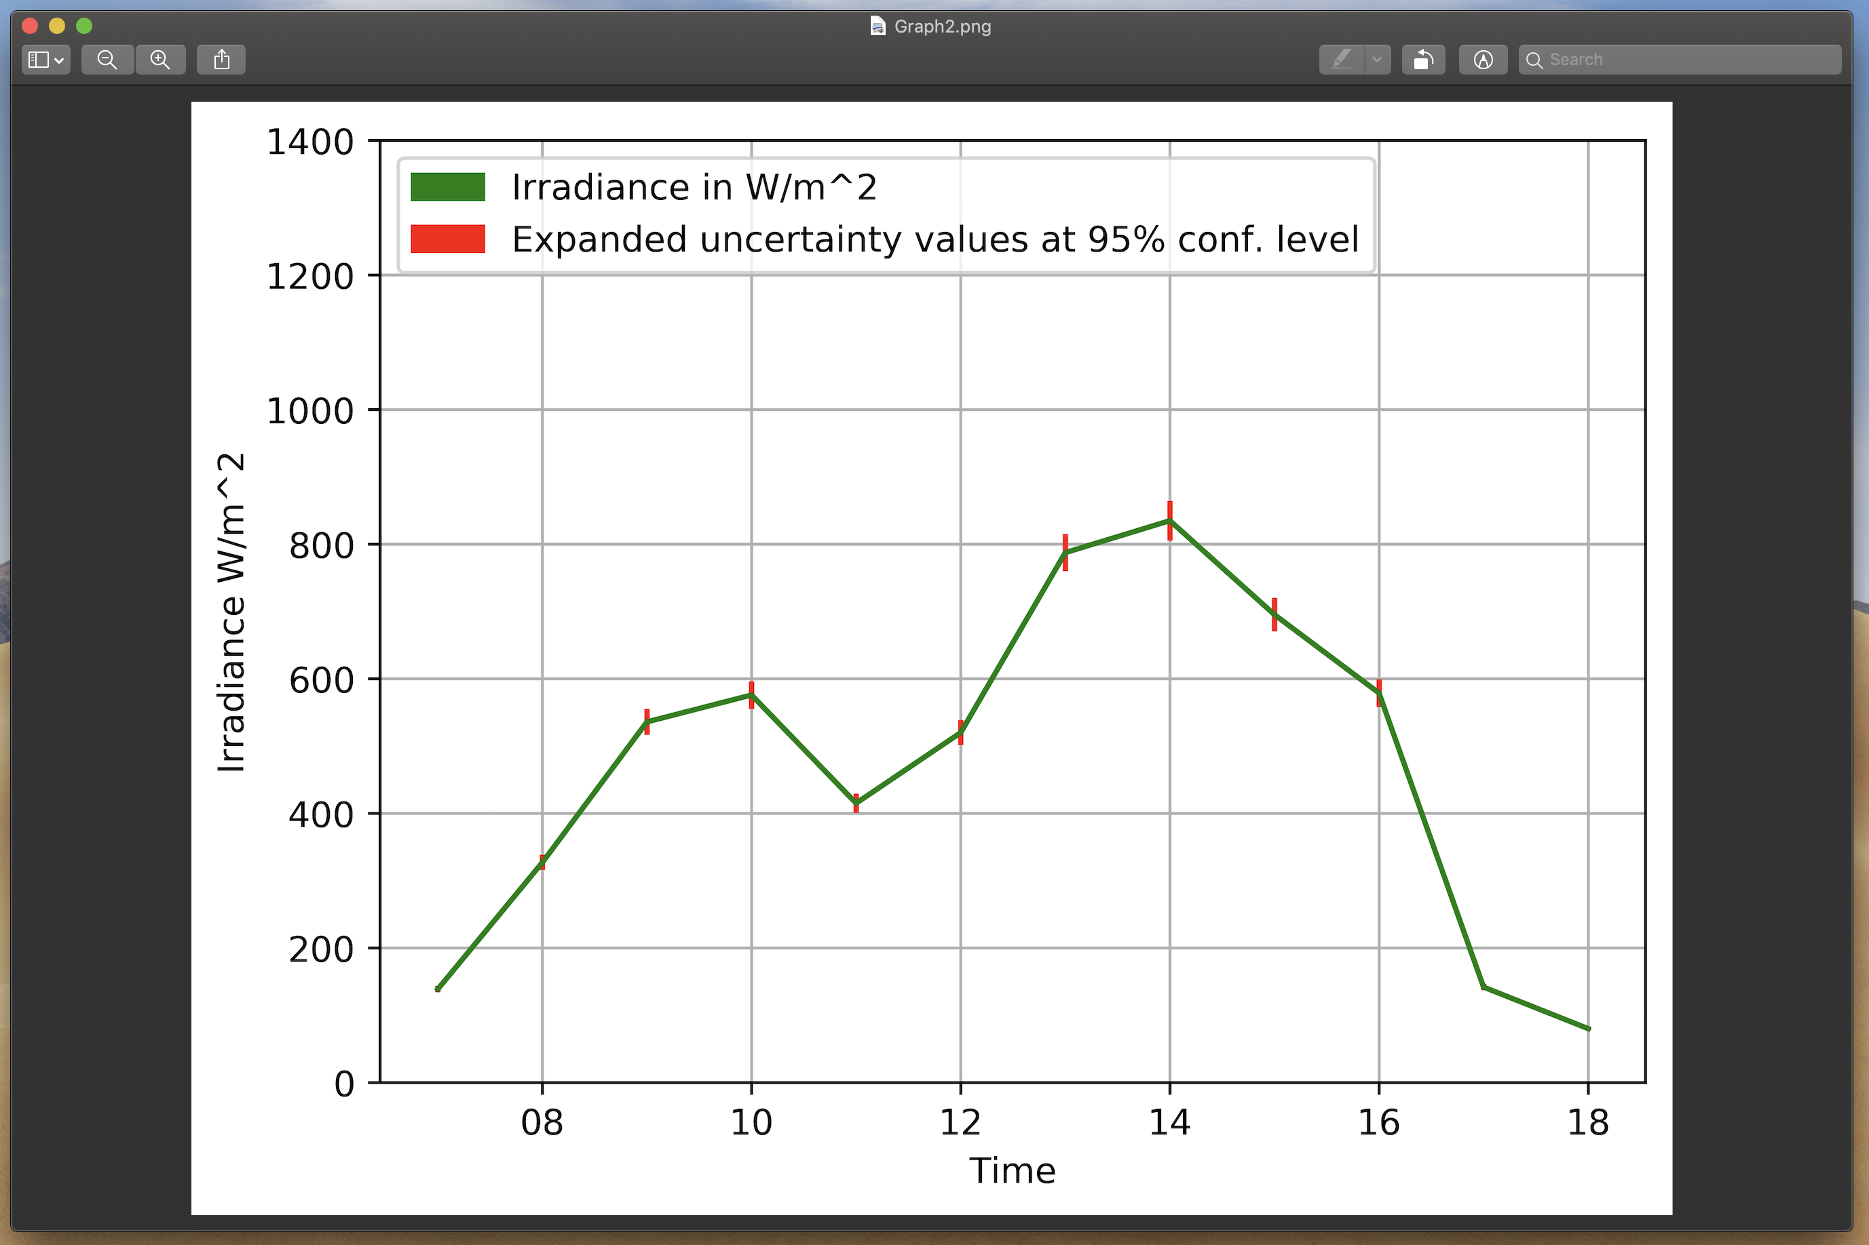

* Graph #2: For Minutes Data

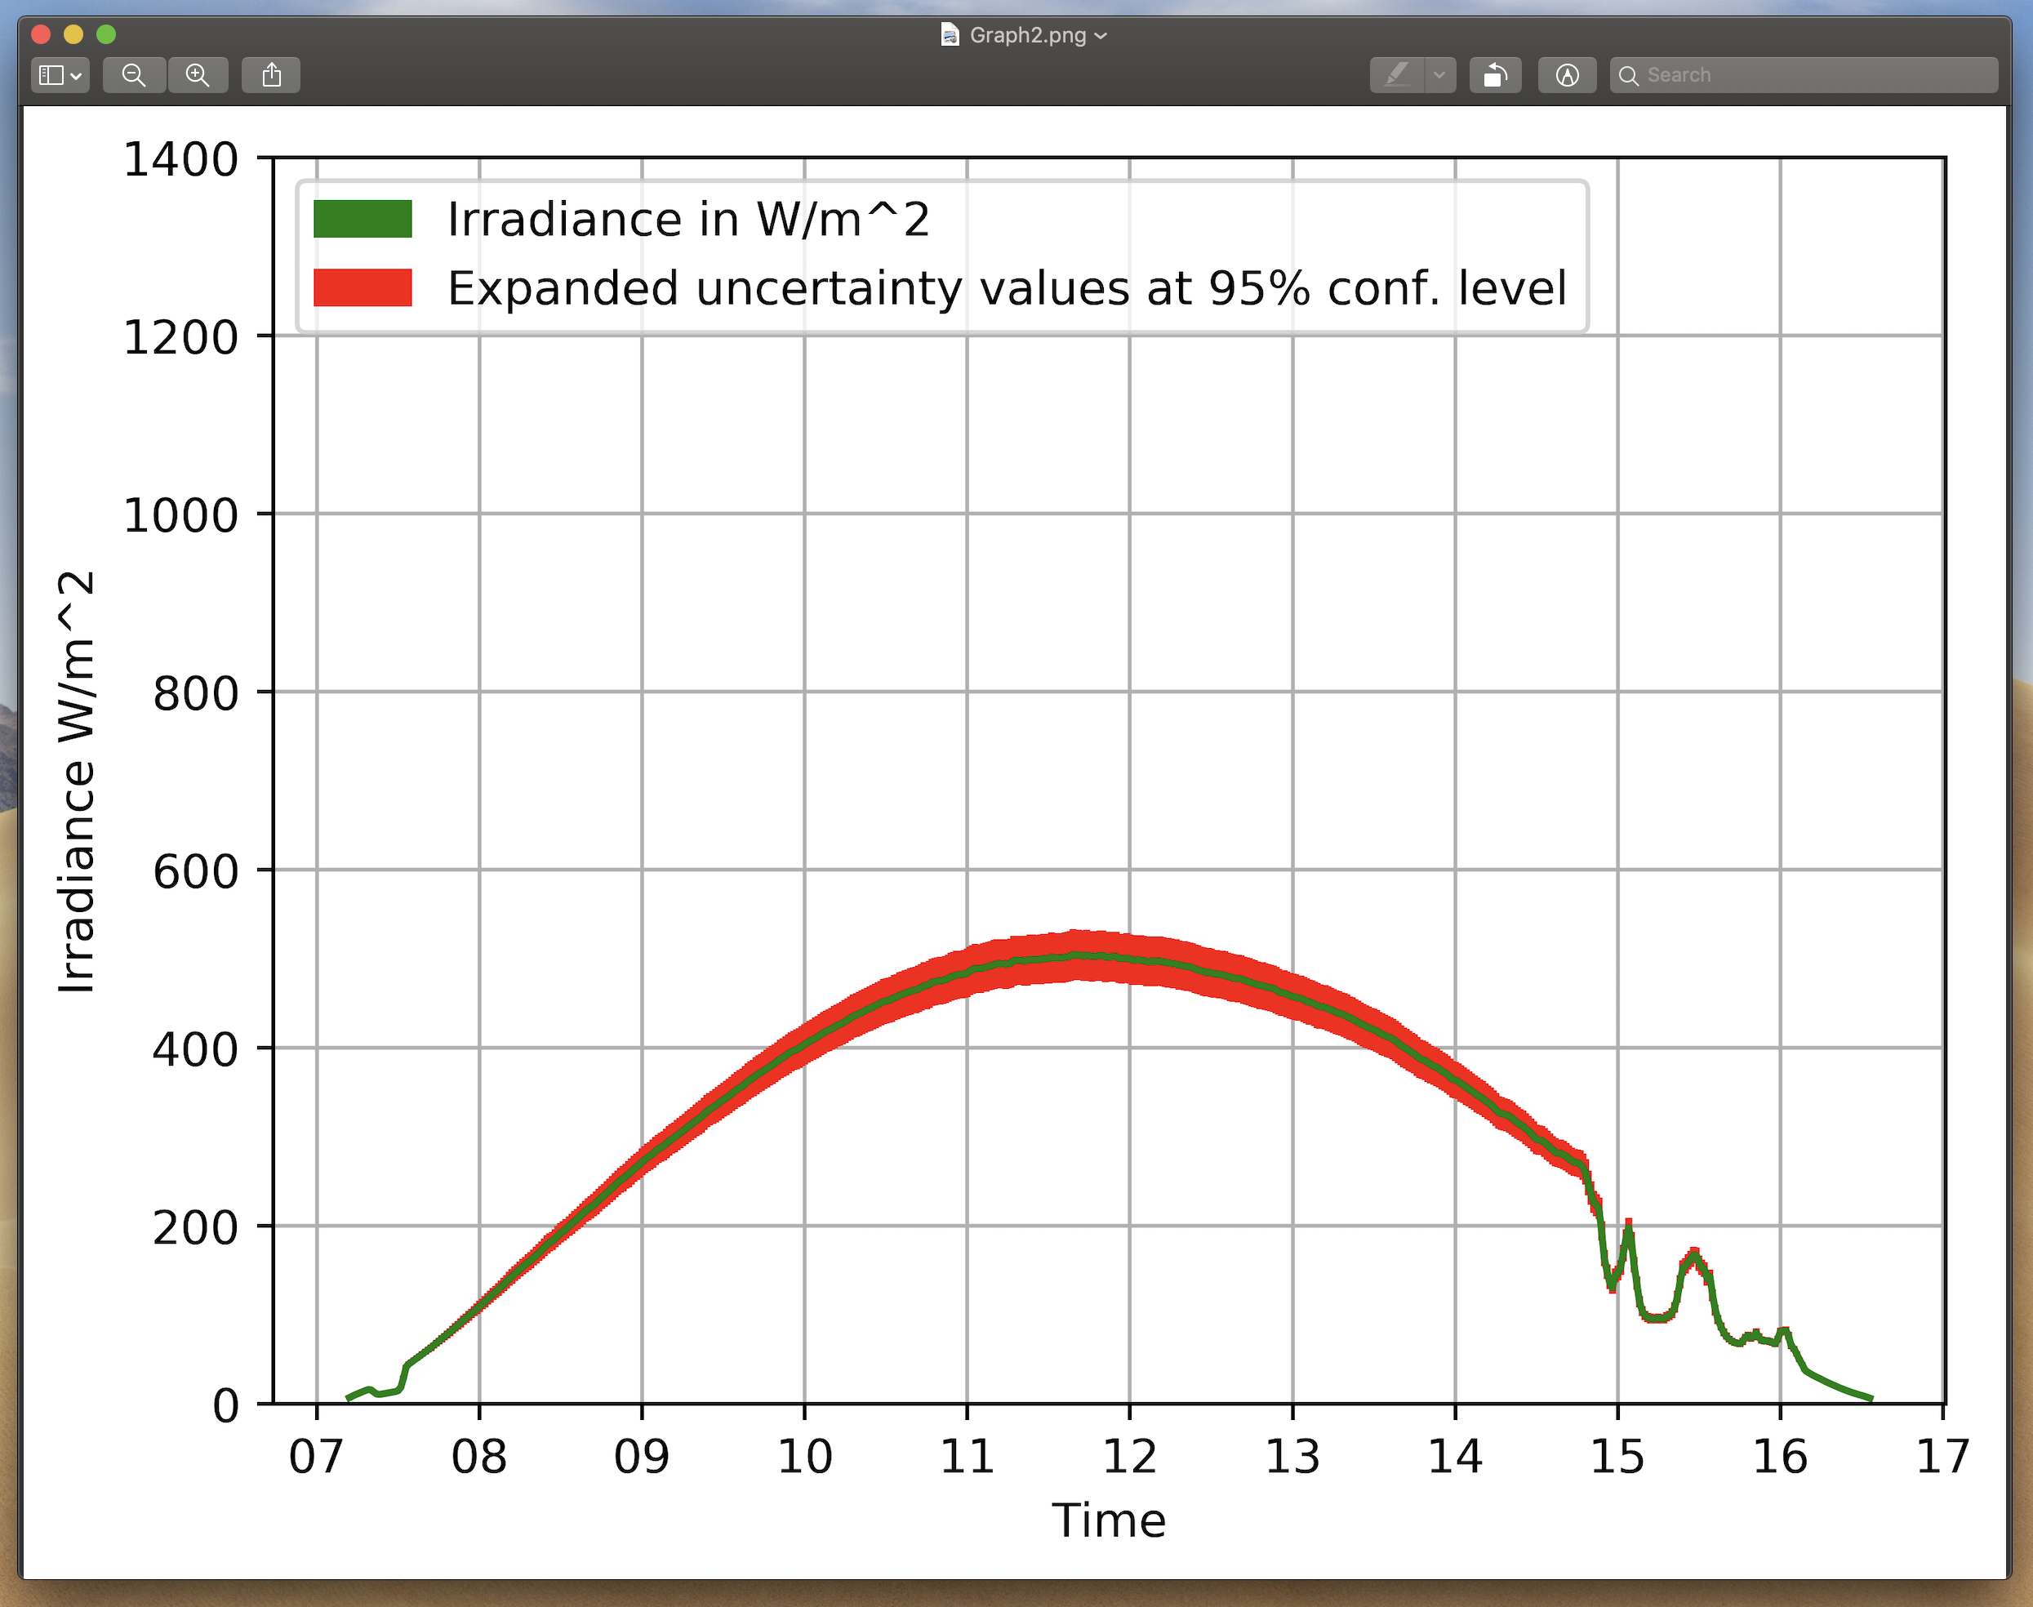

**# How to use the application?**

**For Windows:** Just open the provided Exe file > provide the desired excel sheet (format as mentioned above.) > select instrument > select components > select configuration options for each component and submit > Done.

The application gives the path of generated output.

**For Mac:** Just open the provided Exec file > provide the desired excel sheet (format as mentioned above.) > select instrument > select components > select configuration options for each component and submit > Done.

The application gives the path of generated output.

**Application Flow:**

**Step #1:**

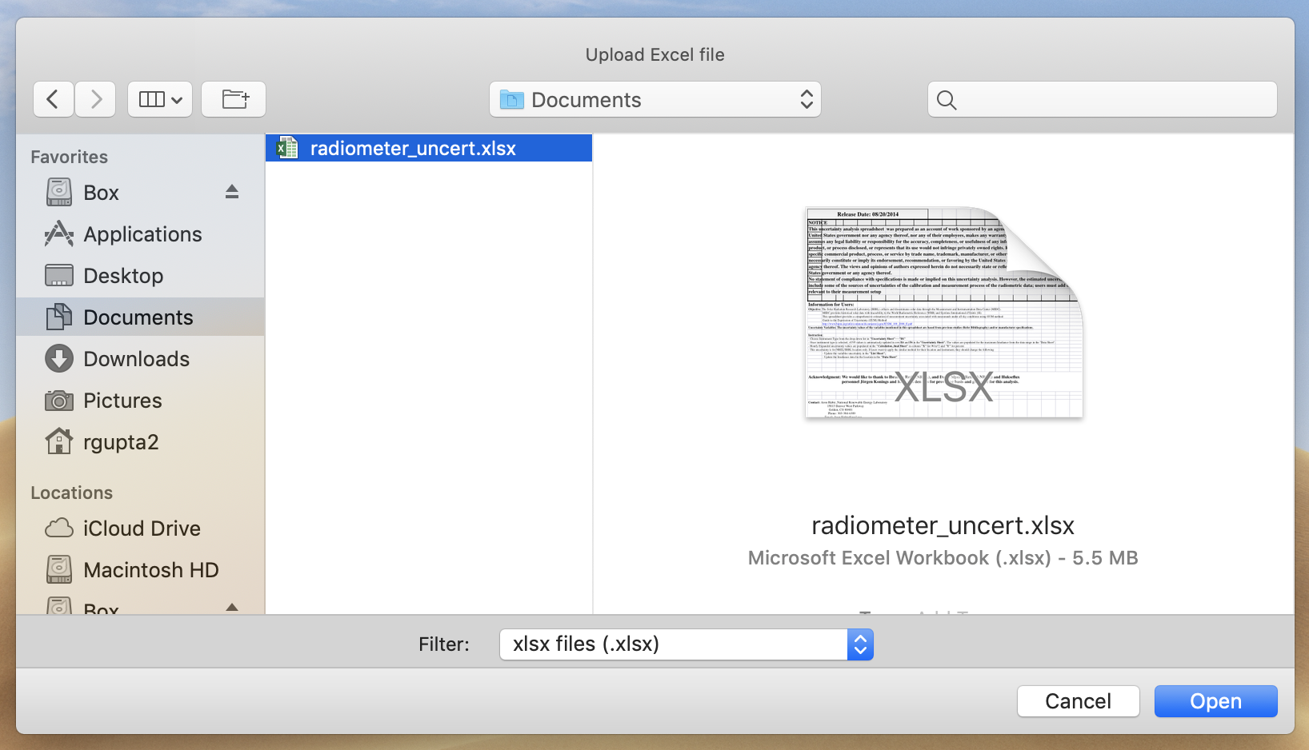

**Step #2:**

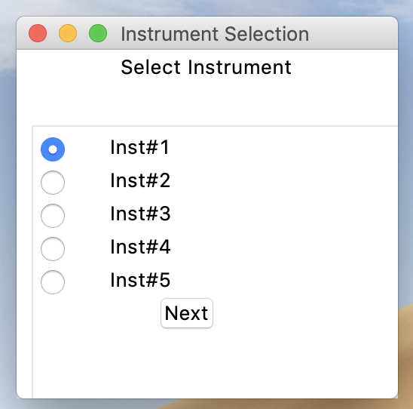

**Step #3:**

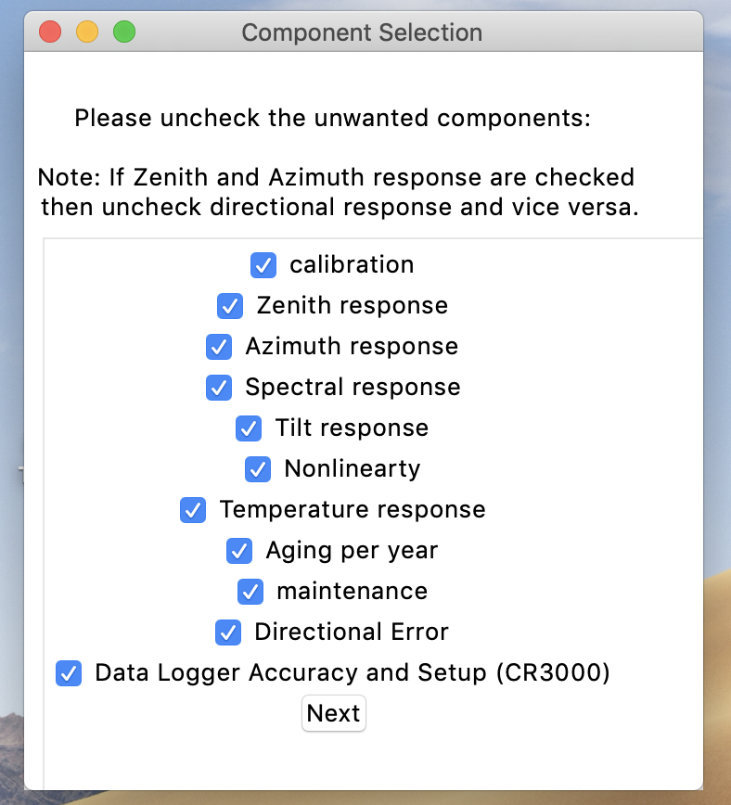

**Step #4:**

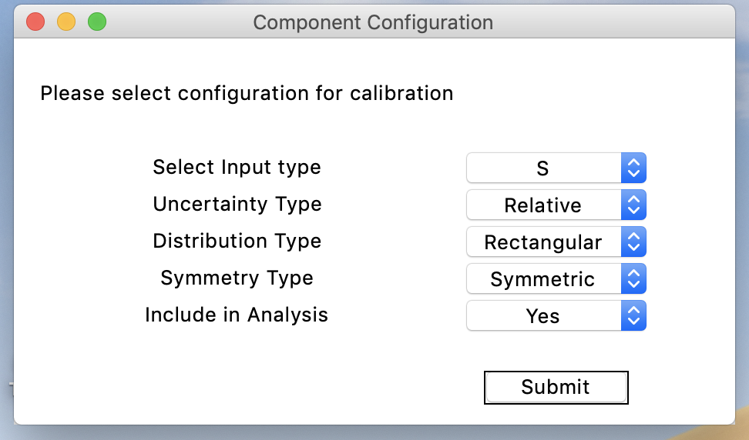

**Step #5:**

